**HOSPITAL MANAGEMNET SYSTEM**

**QUESTION:**

Describe major services (functionality) provided by a hospital's reception. Summary: Hospital Management System is a large system including several subsystems or modules providing variety of functions. Hospital Reception subsystem or module supports some of the many job duties of hospital receptionist. Receptionist schedules patient's appointments and admission to the hospital, collects information from patient upon patient's arrival and/or by phone. For the patient that will stay in the hospital ("inpatient") she or he should have a bed allotted in a ward. Receptionists might also receive patient's payments, record them in a database and provide receipts, file insurance claims and medical reports.

**AIM:**

To design a **Use Case Diagram** for the **Hospital Reception System**, which models patient registration, appointment scheduling, admissions, payments, and insurance claims.

**PROCEDURE**

1. **Identify Actors** – Patient, Receptionist, Doctor, Insurance Provider.
2. **Define Use Cases** – Scheduling, Registration, Payment Processing, Bed Allocation, etc.
3. **Establish Relationships** – Association, «include», and «extend» connections.
4. **Draw Use Case Diagram** – Represent actors and their interactions with the system.

**DIAGRAM:**

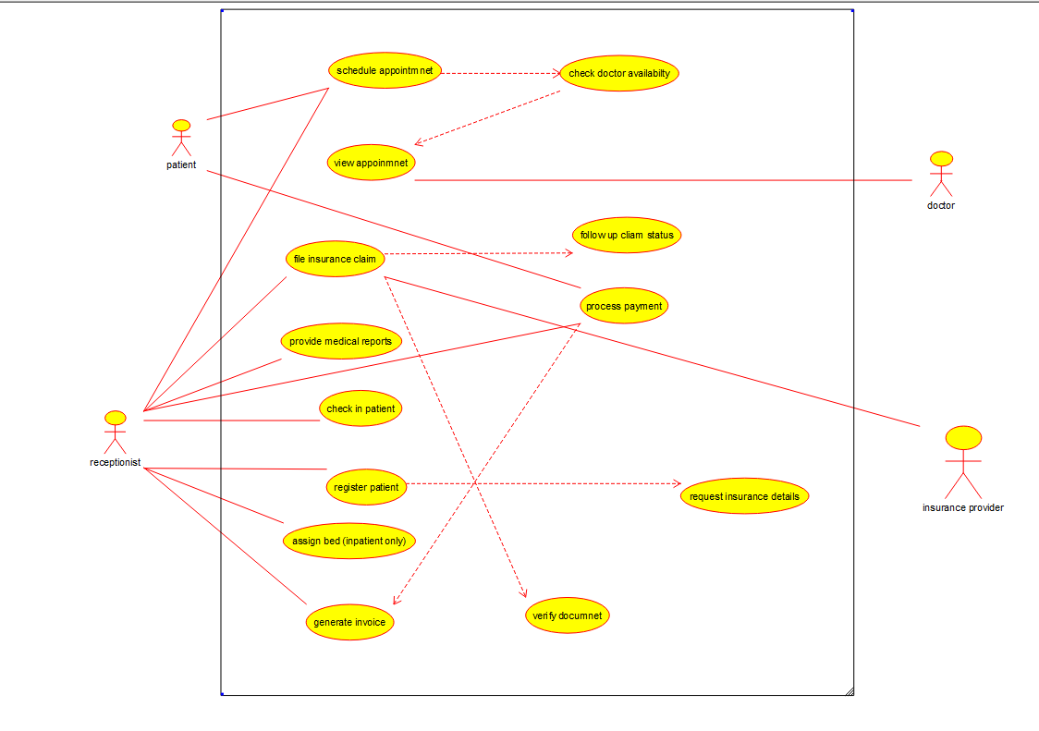

**RESULT**

A **Use Case Diagram** for the **Hospital Reception System** was successfully created.